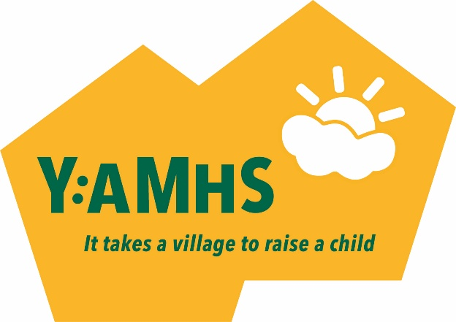
Criteria for provision of funding:
- All applications must be signed by the child / young person’s SENCO or GP.
- All applications must list a named therapist / provider, with appropriate registration with bodies such BACP / UKCP or be listed within the West Sussex Local offer.
- Diagnosis is not necessary, but evidence should be provided as to why a particular diagnosis is suspected and how the therapy will be of benefit.
- Therapies covered include (but are not limited to): CBT, DBT, arts and creative therapies, family therapy, equine therapy, IPT, integrative counselling.
- Not more than £1500 will be allocated to a child / young person in any 12 month period.
- Applications will be prioritised in line with the criteria set out below:
Residency:
- Crawley Borough Council
- Copthorne, Faygate, Pease Pottage, Handcross
- Colgate, Roffey, Balcombe, Crawley Down, Turners Hill
- Horsham, East Grinstead
Diagnosis / Symptoms consistent with:
- Suicidal Ideation
- Eating Disorders
- Psychosis
- Anxiety
- Depression
Waiting time experienced:
- 6 months or more
- 3 months or more
- 1 month or more

Household income:
- Less than £30,000
- Less than £45,000
- 3. Less than £60,000

*Criteria set out above will be used as a guide to trustees when allocating funds. We aim to be as fair and transparent as possible in the way we allocate funds and to help those most in need. We remain committed to our equality and inclusion policy in all decisions made. Mental illness can be very complex, however, and trustees reserve the right to use discretion when awarding grants.

